EXP 2

AIM: Write a C program to simulate a Deterministic Finite Automata (DFA) for the given language representing strings that start with 0 and end with 1

INPUT:

#include<stdio.h>

#include<conio.h>

#include<string.h>

void validate();

int s_table[3][2]={{1,5},{1,2},{1,2}};

char str[10];

int main(){

printf("\n\tTHIS DFA WILL HANDLE THE STRINGS WHICH START WITH 0 AND END WITH 1");

printf("\nEnter any string: ");

scanf("%s",str);

validate();

}

void validate(){

int l,x,i,k,c_state=0,f_state=2;

l=strlen(str);

if(str[0]=='0')

printf("0");

for(i=0;i<l;i++){

if(str[i]=='0')

x=0;

if(str[i]=='1')

x=1;

c_state=s_table[c_state][x];

printf("--->%d",c_state);

if(c_state==5)

break;

}

if(c_state==f_state)

printf("\nVALID STRING");

else

printf("\nINVALID STRING");

}

OUTPUT:

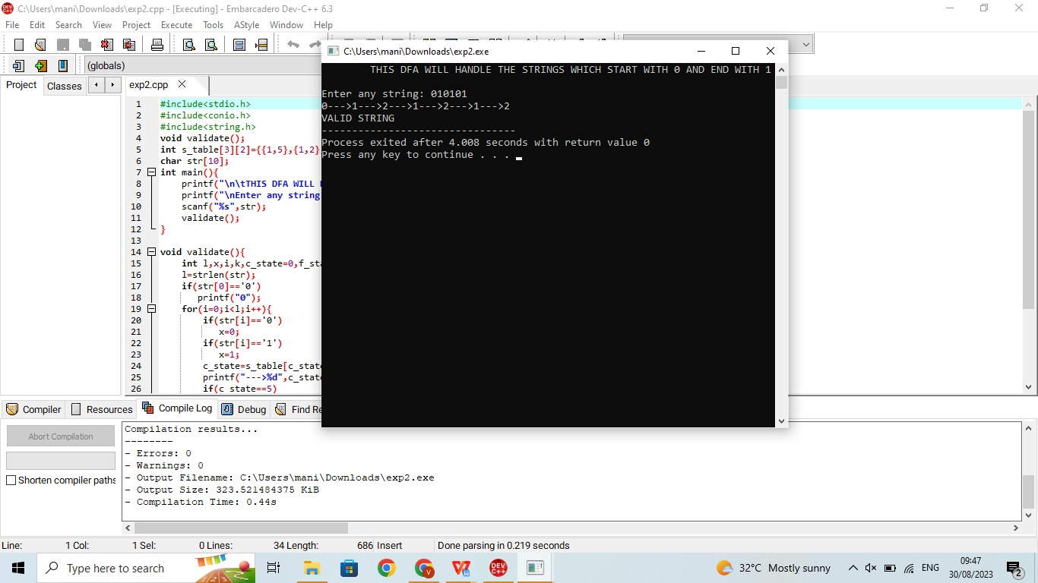

RESULT:The programm is successfully executed in devc++